

**Phishing Attack Domain Detection**

## Overview

This project focuses on solving the most common cyber attack called phishing. Phishing is a type of social engineering attack often used to steal user data, including login credentials and credit card numbers.

In the previous HLD and LLD documents we discussed the problem statement and the technical solution we are trying to build for it. In this ‘Detailed Project Report’, we’ll discuss other aspects of the project like Resources,Budget and Timelines

# Made by Deepesh Mhatre

## Project Operations

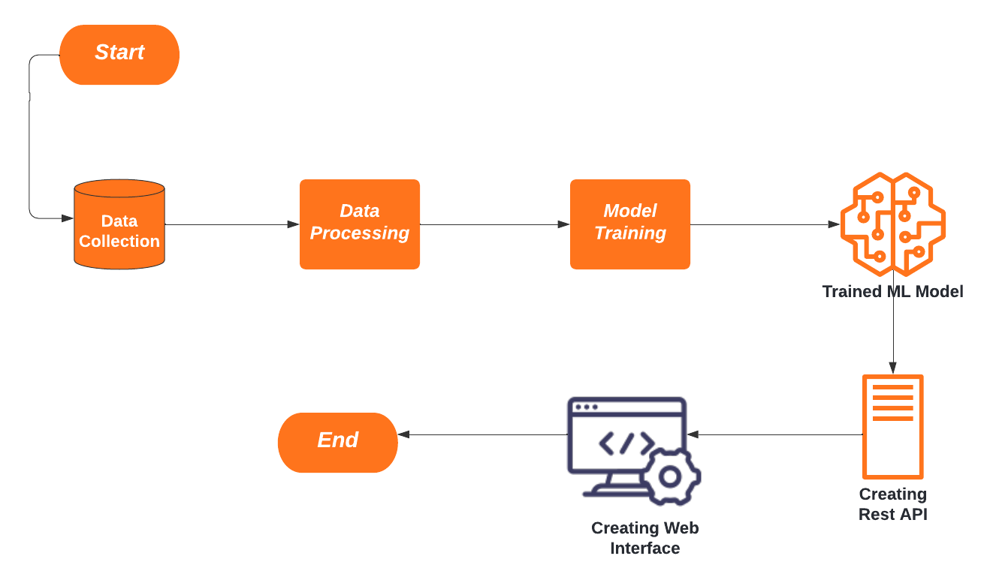As discussed in previous documents, below are the series of tasks to be completed in this project.

Made by Deepesh Mhatre

Each task is to be performed in a sequential manner as each is dependent on the result of its previous task. Also for maintaining quality of the project, developers are allowed to iterate through the loop until they reach a satisfactory project result.

## Project Timeline

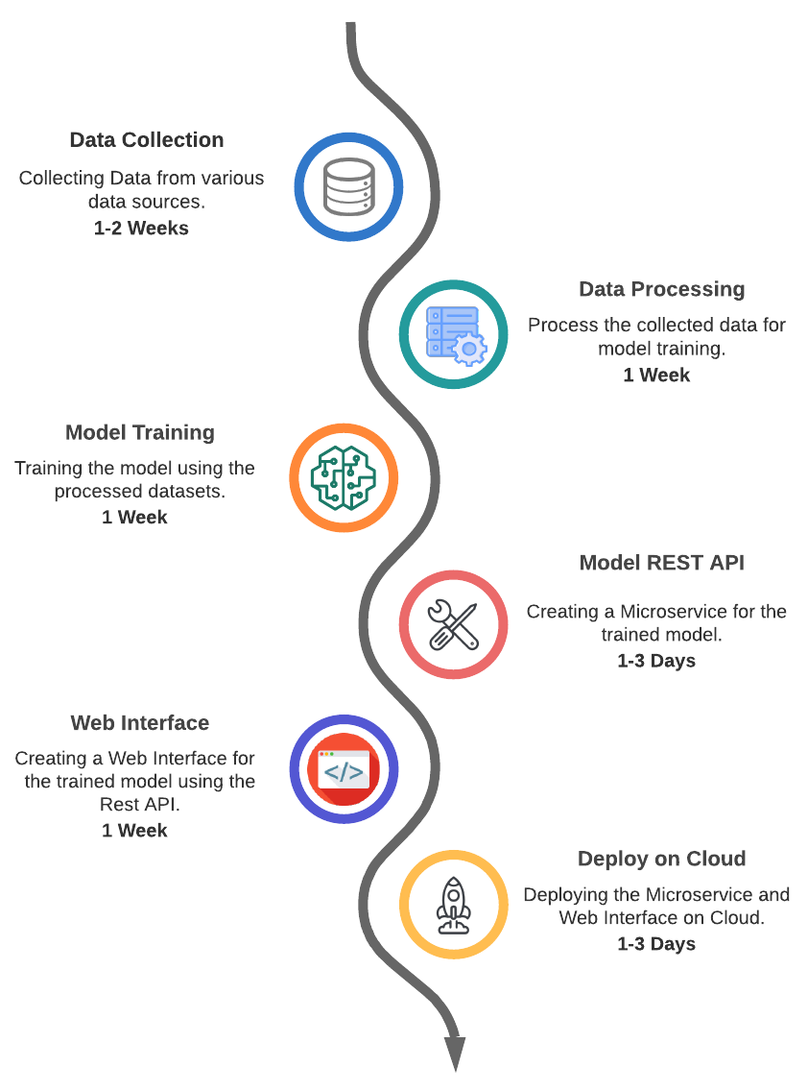

The below diagram describes the amount of time needed to successfully complete each task in the workﬂow. In total the total amount of time needed to complete the project is approximately 3-4 Weeks.

# Made by Deepesh Mhatre

## Project Budget

The most promising aspect of a software project is that the Marginal cost is almost zero, and it's very easy to get started with only a small budget.

Below are the costs for some of the resources and tools we’ll be using in this project. Note that we’ll not be accounting for any employee or service cost as it's relative to each employer.

### Data Collection (Cost : 0$)

For this phase of our project we will mostly be using free public datasets so there is not cost to be accounted here.

### Data Processing & Model Training

Made by Deepesh Mhatre

Dealing with large datasets and training production-ready models also comes with expensive computational needs, therefore we’ll be using special cloud services which provide high computation CPU environments for dealing with such tasks.

### Deployment Services

For deployment of our model we’ll be using cloud services which will host our models. At the start since we don't have many users,we may not be charged for hosting our services, but as our users grow our costs will also rise per usage.

Made by Deepesh Mhatre